Functions (Procedural Oriented Programming)

Content

- What is procedural oriented Programming?
- Advantage of procedural oriented programming
- What is function?
- Advantage of writing function
- Defining function
- Calling the function
- Local variables
- Global variables
- Function with parameters
  - Required parameters
    - Required positional parameters
    - Required keyword parameters
  - Default parameters
  - Variable length parameters
    - Variable length positional parameters
    - Variable length keyword parameters
- Function with return value
- Generator Functions
- Decorator Functions
- Closure Functions
- Lambda Functions
- Recursive Functions

What is procedural oriented programming (POP)?
Python is a multiple paradigm programming language. A programming paradigm defines set of rules and regulations for writing or organizing code or instructions.

Types of programming paradigms
- Procedural Oriented Programming (POP)
- Modular Oriented Programming (MOP)
- Object Oriented Programming (OOP)
- Functional Oriented Programming (FOP)
Why Procedural oriented programming?
In procedural oriented programming instructions are organized according to their operation by dividing into small pieces called sub routines.
What is sub routine?
A sub routine is small program within program.
These sub routines are called,
- Procedures
- Functions
What is advantage of procedural oriented programming?
- Reusability
- Modularity
- Readability
- Efficiency
Reusability: It allows writing code once use many times
Modularity: dividing code according their operations into small pieces
Readability: Easy to understand
Efficiency: It reduce size of the program which increases efficiency of program.

In python procedural oriented programming is implemented using functions.

What is function?
A function is small program within program.
A function is named block, which contains set of instructions to perform some operation.
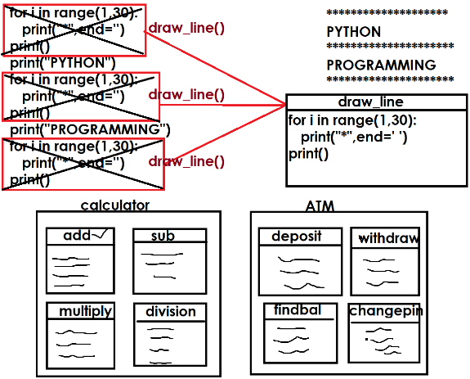
Advantage of writing function
- Modularity
- Readability
- Reusability
- Efficiency

Functions are 2 types
- Predefined functions
- User defined functions

Predefined functions
The existing functions are called predefined functions.
These predefined functions are also called library functions.
Example: print(),input(),oct(),hex(),bin(),chr(),ord(),int(),float(),…

User defined functions
The functions developed by programmer are called user defined functions.
These are application specific functions.

Basic steps for working functions
- Defining function (OR) Writing Function
- Invoking function (OR) Calling Function

Defining function (OR) Writing functions
In python a function is defined or written by using “def” keyword.

Syntax:
def function-name([parameters]):
statement-1
statement-2

A function is self contained block which contains set of instructions to perform some operations.

A function is defined,
- With parameters
- Without parameters

A function with parameters receives values.
A function without parameters does not receive values.

Example:
def fun1():
print("function without parameters")

def fun2(a,b):
print("function with parameters")

# writing function or defining function  def fun1():  print("Welcome to functions")  # calling function or invoking function  fun1()  fun1()  fun1()  fun1()  fun1() | Output  Welcome to functions  Welcome to functions  Welcome to functions  Welcome to functions  Welcome to functions
After defining the function or writing the function, it has be called as an executable statement. Function is not called or executed automatically.

def deposit():  print("inside deposit")  def withdraw():  print("inside withdraw")  def findbal():  print("inside findbal")  #ATM  #Main Program  while True:  print("1. Deposit")  print("2. Withdraw")  print("3. Finding Bal")  print("4. Exit")  opt=int(input("Enter your option "))  if opt==1:  deposit()  elif opt==2:  withdraw()  elif opt==3:  findbal()  elif opt==4:  break | Output  1. Deposit  2. Withdraw  3. Finding Bal  4. Exit  Enter your option 1  inside deposit  1. Deposit  2. Withdraw  3. Finding Bal  4. Exit  Enter your option 2  inside withdraw
Example:  def drawline():  for i in range(40):  print("*",end='')  print()  #Main Program  drawline()  print("PYTHON")  drawline()  print("PROGRAMMING")  drawline()  print("LANGUAGE")  drawline() | Output:  ****************************************  PYTHON  ****************************************  PROGRAMMING  ****************************************  LANGUAGE  ****************************************

Whenever function is called or invoked, the execution control switched from calling place to called function.
After execution of called function, it returns to calling place.
The memory for the function is allocated, whenever function is called or invoked and memory is de-allocated after execution of function.

Local variables
The variables created within function are called local variables.

Syntax:
def function-name([parameters]):
local-variable-name=value
local-variable-name=value

The scope of local variables is within function. This variable cannot accessible outside the function.
These variables are created within function memory area, when function is invoked or called. These variables are deleted after execution function.

Example  def add():  x=100 # Local Variable  y=200 # Local Variable  z=x+y # Local Variable  print(f'sum of {x} and {y} is {z}')  add()  # print(x) Error | Output  sum of 100 and 200 is 300
def fun1():  x=100 # Local Variable  def fun2():  print(x) # Error  fun1()  fun2() | Traceback (most recent call last):  File "D:/Backup/Python7PMOCT/test277.py", line 8, in <module>  fun2()  File "D:/Backup/Python7PMOCT/test277.py", line 5, in fun2  print(x) # Error  NameError: name 'x' is not defined

